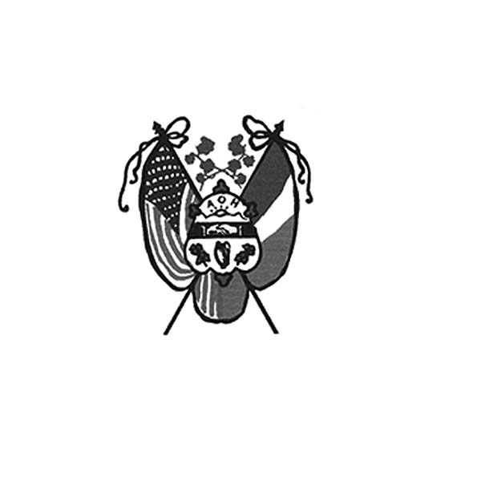 **Ancient Order of Hibernians**

**of Hampden Hampshire Counties**

PO Box 6535

Holyoke, MA 01041-0826

[www.AOH-Holyoke.com](http://www.aoh-holyoke.com/)

Next meeting – AOH – Monday, October 7th, 7 p.m. at

the Irish Cultural Center, Morgan Road, West Springfield

LAOH – Monday, October 7th, 6 p.m. at The Wherehouse?

​**In ainm an Athar agus an Mhic agus an Spiorad Naoimh, Amen.**

**Dear Brothers,**

**The month of September was very busy with the Parade at the Big E that Peter Hogan organized and the half way to Saint Patrick's Day at the Glendale Winery.** There, we were able to fill the new Polish National Credit Union van with food donations. Thank you to everyone.

**In partnership with the Polish National Credit Union,** the AOH and LAOH are conducting a Food and Clothing Drive for Providence Ministries through December. Non-perishable food items, sleeping bags, blankets and gently worn clothing can be dropped off at PNCU insurance service, 270 Westfield Road. Don’t forget to enter the raffle for a $100 and a giant raffle basket. We value our partnership with PNCU to assist Providence Ministries each year and are grateful for the support from Hibernian Jim Kelly, CEO of PNCU.

**Our October meeting will be held on Monday, October 7, 7 p.m. at the Irish Cultural Center, 429 Morgan Road, West Springfield.** Pizza will be served at the end of the meeting. There will also be a cash bar.

**Finally, nomination for officers will reopen and close at the October meeting.**

**Thank you to David Bartley for pulling some strings and getting more AOH members into the Big E Parade on Holyoke Day.** JD and Paula cruised comfortably in JD’s vintage hot rod, while the rest of the AOH and LAOH contingents rode in the trolley.

**Our fiscal year for your 2025 dues starts in November of 2024. As an AOH incentive, we will be holding a $50.00 gift card raffle for J P's restaurant which will be drawn at our adult Christmas party / meeting.** To be eligible for this drawing please send in your dues by 10/23/2024. Dues are $30.00 per year. Please make a check out to AOH and send it to: AOH, PO box 6535, Holyoke MA. 01041-6535. Please contact Peter Hogan (financial secretary) if you have any questions on your dues. He can be reached at 413-330-6635 or pjhogan71@gmail.com

**Newly-arrived AOH Polo shirts are available for sale for $70.** They come in all sizes. To purchase your shirt, please contact President O’Connor at 413-627-7148.

**Pete’s Calendar March 2025 Saint Patrick’s raffle tickets** will be available at the October meeting.

**The AOH 50/50 drawing has increased from $1.00 to $2.00.** There will be no 50/50 for October, because the AOH meeting will take place at the Irish Cultural Center, instead of at the Wherehouse?.

*To Be Irish Is A Blessing, To Be a Hibernian an Honor*

**LAOH Notes**

**We are grateful to everyone who volunteered at the LAOH Par 3 Golf Tournament and helped make it another success.** Please bring any receipts or proceeds to the meeting on October 7th at 6:00 at the Wherehouse?.

**Thank you to our members who generously donated to the Holyoke Veterans' Home (formerly the Holyoke Soldiers' Home).** Three large bags of donations were delivered a few days after the golf tournament. We will continue to deliver donations as they come in. Our veterans are so deserving of our support.

A wish list for the veterans will be attached to this newsletter. If you were unable to make a donation at the golf tournament, and would like to bring something to the meeting, it will be delivered to the Veterans’ Home.

**There will be nominations for officers at the October meeting,** with elections taking place in November. More information will be available at the October meeting.

**The LAOH will be making PB&J sandwiches for Kate’s Kitchen, October 27, November 24, and December 15.**

**Contact Paula Paoli at 413-210-6031, or paulaakpaoli@gmail.com; or Pat Murphy at 413-532-3121, if you are unsure if your 2024 dues are paid.**

**If you are receiving a printed copy of the newsletter and want it sent by email instead,**please contact Paula Paoli at  [**paulaakpaoli@gmail.com**](mailto:paula5412@comcast.net) or 413-210-6031 to make the change.  We appreciate those who have changed to email to save our division the cost of printing and postage.

**The LAOH October meeting will take place at the Wherehouse as usual.**

*To Be Irish Is A Blessing, To Be a Hibernian an Honor*

**Upcoming Events:**

**Sandwiches for Kate’s Kitchen –**If you would like to join us, please contact Rosalie Pratt at 413.532.1677 to

volunteer. Tentative schedule dates for sandwich making are October 27, November 24, and December 15.

**Food and Clothing Drive for Providence Ministries** - September through December. Drop off items at the PNCU, 270 Westfield Road, Holyoke.

**Nomination for Club Offices** - submissions at the October meeting with elections in November.

**Adult Christmas Party** – Monday, December 2, 7 p.m. at JP’s Restaurant. More details to follow.

**Children’s Christmas Party** – date to be determined. Kit Collamore is chairing the fun.

**ICC News**

**The Trinity Pub**

The Trinity Pub is open Wednesday–Saturday with the pub open from 4 – 10 p.m. and dinner served from 5 – 9 p.m. For reservations and gift certificates call 413-342-4358.

**Irish Cultural Center Book Club**

**Join the Irish Cultural Center Book Club.** Enjoy good craic and delve into Irish and Irish-American literature, with guided discussion in a welcoming, relaxed atmosphere. This event is open to all, Patrons and the general public. The meeting will take place on Thursday, October 10 from 5:30–6:30 pm at the ICC. This month’s selection is *The Last September* by Elizabeth Bowen.

**Entertainment at the Trinity Pub –** Wednesdays, October 3, 10, 17, 24 & 31- Trad Seisun; Fridays, October 4 – Brother by Law: October 11 – Dan Ringrose; October 18- Baird Souls; October 25 – Piper-Hopkins Band; Saturdays, October 5 – The Blaney Brothers: October 12 – Jimmy McArdle and Jerry Murphy: October 19 – Dee Reilly: October 26 – The Healys.

**Remember the AOH in Your Will**

**Please consider the Order when writing or rewriting your will,** and add a paragraph with the lines of “I leave to the Ancient Order of Hibernians in America (X percent of my estate or a specific dollar amount) for its charitable works.”

**The Healy’s Irish Radio program is on the air every Saturday from 9 a.m – 11 a.m. on WARE Radio, 97.7 FM and 1250 AM. It is also streamed online at classichits977.com and available anytime at healysirishprogram.com.**

**In continued memory of Doc Dean and our commitment to Kate’s Kitchen.**  Providence Ministries is in need of canned goods. Please bring a can or two to the meeting on Monday night.

**Tim O’Shea’s name was picked for the 50/50 raffle.** Tim was not in attendance at the meeting. You have to be present to win.

* On a sad note please pray for Brother Tim O’Shea and his family on the passing of his mother, Cecelia.

**(**Editor’s Choice) If you remember Tracy Cole or Richard Lavigne on WREB, tune your smart phone or go onto your computers to RTE Radio. My favorite is “The Joe Duffy Show on RTE 1 (Irish radio) program weekday from 8:45 am to 10 am. Joe is the most popular talk show host, has fascinating guests and interesting stories.

If any reader has other interesting social media sites on Irish history, culture, sport, or politics send me the link and I’ll share in the next issue. Owen Donohue at [Helloh@aol.com](mailto:Helloh@aol.com)

**In ainm an Athar agus an Mhic agus an Spiorad Naoimh, Amen**

