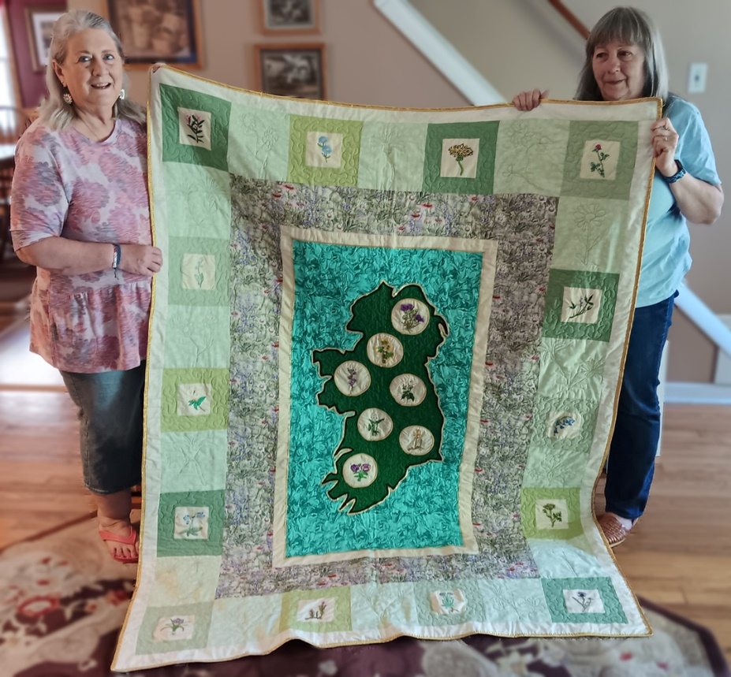

Thank you to everyone who supported the LAOH 2024 Irish Quilt raffle
The winning ticket was drawn at the MITCHELL’S PUBLIC HOUSE
on MAY 11, by Orla Mitchell.
The winner is Denise Fitzell, of South Hadley, MA
Proceeds from the raffle go towards scholarships for members of the
LAOH, and AOH, and to other charities in the Holyoke area that are supported by the Ladies Ancient Order of Hibernians
Paula Paoli – Quilt Fundraiser Chair
Pres., LAOH, Holyoke, MA, Past LAOH MA State Pres.

